**Name: Deepankar Sharma course: BCA-6th roll no: 2092014**

**Subject: Scripting Languages**

|  |  |  |  |
| --- | --- | --- | --- |
| **Index** | | | |
| **S. No.** | **Objective** | **Date** | **Signature** |
| 1 |  |  |  |
| 2 |  |  |  |
| 3 |  |  |  |
| 4 |  |  |  |
| 5 |  |  |  |
| 6 |  |  |  |
| 7 |  |  |  |
| 8 |  |  |  |
| 9 |  |  |  |
| 10 |  |  |  |
| 11 |  |  |  |
| 12 |  |  |  |
| 13 |  |  |  |

Name: Deepankar Sharma

Course: BCA

University Roll No: 2092014

Subject: Scripting Languages

Date: 17-02-23

**Practical 01: To implement Lists in HTML**

<!-- To implement List in HTMl -->

<!DOCTYPE html>

<head>

<title>List</title>

</head>

<body>

<ul style="list-style-type:square;">

<li>Coffee</li>

<li>Tea</li>

<li>Milk</li>

</ul>

<ol>

<li>Coffee</li>

<li>Tea</li>

<li>Milk</li>

</ol>

<dl>

<dt>Coffee</dt>

<dd>- black hot drink</dd>

<dt>Milk</dt>

<dd>- white cold drink</dd>

</dl>

</body>

</html>

**Output:**

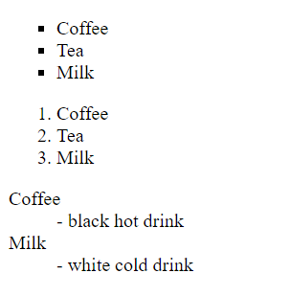

Name: Deepankar Sharma

Course: BCA

University Roll No: 2092014

Subject: Scripting Languages

Date: 3-03-2023

**Practical 02: To implement Tables in HTML**

<!-- implement table in HTML -->

<html>

<head>

<title> Table </title>

</head>

<body>

<br><br><br><br><br><br><br><br>

<table align=center border="1" cellpadding="2">

<caption align="top"><b>Specification Table with Hoursand Marks<caption>

<tr>

<th rowspan="2"> Unit No. </th>

<th rowspan="2"> Unit Title </th>

<th rowspan="2"> Teaching Hours </th>

<th colspan="4"> Distribution of Theory Marks </th>

</tr>

<tr>

<td>R Level </td>

<td>U Level </td>

<td>A Level </td>

<td>Total Marks </td>

</tr>

<tr>

<td>

<center>I

</td>

<td>Introduction to Internet Technology</td>

<td>

<center>2

</td>

<td>

<center>4

</td>

<td>

<center>4

</td>

<td>

<center>0

</td>

<td>

<center>8

</td>

</tr>

<tr>

<td>

<center>II

</td>

<td>Basic of HTML & CSS</td>

<td>

<center>6

</td>

<td>

<center>0

</td>

<td>

<center>2

</td>

<td>

<center>6

</td>

<td>

<center>8

</td>

</tr>

<tr>

<td>

<center>III

</td>

<td>Active Server Pages 3.0</td>

<td>

<center>6

</td>

<td>

<center>4

</td>

<td>

<center>8

</td>

<td>

<center>0

</td>

<td>

<center>12

</td>

</tr>

<tr>

<td>

<center>IV

</td>

<td>Server Side Coding with VBScript and XML</td>

<td>

<center>8

</td>

<td>

<center>2

</td>

<td>

<center>4

</td>

<td>

<center>8

</td>

<td>

<center>14

</td>

</tr>

<tr>

<td>

<center>V

</td>

<td>ASP Objects & Components</td>

<td>

<center>10

</td>

<td>

<center>4

</td>

<td>

<center>4

</td>

<td>

<center>6

</td>

<td>

<center>14

</td>

</tr>

<tr>

<td>

<center>VI

</td>

<td>Accessing database with ASP & ADO</td>

<td>

<center>10

</td>

<td>

<center>4

</td>

<td>

<center>4

</td>

<td>

<center>6

</td>

<td>

<center>14

</td>

</tr>

<tr>

<td></td>

<th>

<center>Total

</th>

<th>

<center>42

</th>

<th>

<center>18

</th>

<th>

<center>26

</th>

<th>

<center>26

</th>

<th>

<center>70

</th>

</tr>

</table>

</body>

</html>

**Output:**

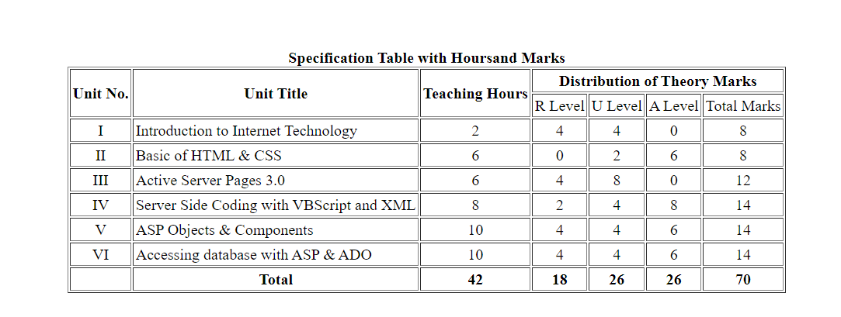

Name: Deepankar Sharma

Course: BCA

University Roll No: 2092014

Subject: Scripting Languages

Date: 17-03-2023

**Practical 03: Implementation of popup of alert and confirm.**

<!-- Implementation of popup of alert and confirm. -->

<!DOCTYPE html>

<html>

<head>

    <title>Popup Box Example</title>

</head>

<body>

    <h1>Popup Box Example</h1>

    <button onclick="showAlert()">Show Alert</button>

    <button onclick="showConfirm()">Show Confirm</button>

    <script>

        function showAlert() {

            alert("This is an alert message!");

        }

        function showConfirm() {

            var result = confirm("Are you sure you want to delete this item?");

            if (result == true) {

                alert("You clicked OK!");

            } else {

                alert("You clicked Cancel!");

            }

        }

    </script>

</body>

</html>

**Output:**

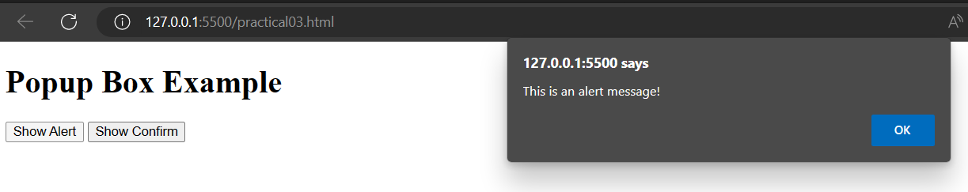

Name: Deepankar Sharma

Course: BCA

University Roll No: 2092014

Subject: Scripting Languages

Date: 24-03-2023

**Practical 04: Implementation of the CSS Box Model.**

<!-- Implementation the CSS Box Model. -->

<!DOCTYPE html>

<html>

<head>

    <title>CSS Box Model Example</title>

    <style>

        /* Define styles for the outer box */

        .outer-box {

            width: 200px;

            height: 200px;

            background-color: lightblue;

            border: 10px solid black;

            padding: 20px;

            margin: 50px;

        }

        /* Define styles for the inner box */

        .inner-box {

            width: 100%;

            height: 100%;

            background-color: white;

            border: 10px solid red;

            padding: 20px;

            box-sizing: border-box;

        }

    </style>

</head>

<body>

    <div class="outer-box">

        <div class="inner-box">

            This is an example of the CSS box model.

        </div>

    </div>

</body>

</html>

<!-- The CSS box model is a container that contains multiple properties including borders, margin, padding, and the content itself. It is used to create the design and layout of web pages. It can be used as a toolkit for customizing the layout of different elements.  -->

**Output:**

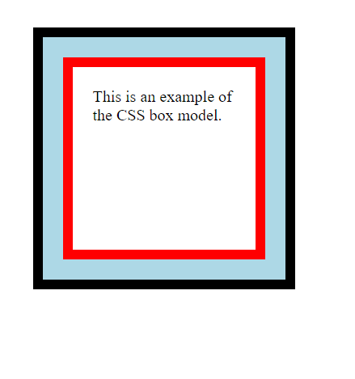

Name: Deepankar Sharma

Course: BCA

University Roll No: 2092014

Subject: Scripting Languages

Date: 24-03-2023

**Practical 05: Design the webpage by applying the different style using inline, internal and external style sheet.**

<!-- Design the webpage by applying the different style using inline, internal and external style sheet. -->

<!DOCTYPE html>

<html>

<head>

    <title>Styles Example</title>

    <!-- Internal Styles -->

    <style>

        h1 {

            color: blue;

            font-size: 36px;

            text-align: center;

        }

        p {

            font-size: 20px;

            line-height: 1.5;

        }

    </style>

    <!-- External Styles -->

    <link rel="stylesheet" type="text/css" href="practical05.css">

</head>

<body>

    <!-- Inline Styles -->

    <div style="background-color: yellow; padding: 20px;">

        <h1 style="color: red;">Styles Example</h1>

        <p style="text-align: justify;">This is an example of applying styles using inline, internal and external style

            sheets. The heading is styled with inline styles, the paragraph is styled with internal styles, and the

            background color and padding of this div are styled with inline styles.</p>

    </div>

    <!-- External Styles -->

    <div class="external-styles">

        <h2>External Styles</h2>

        <p>This div is styled using an external style sheet.</p>

        <button class="btn">Click me</button>

    </div>

</body>

</html>

**CSS:**

/* External Styles */

.external-styles {

background-color: lightblue;

padding: 20px;

}

.external-styles h2 {

color: white;

font-size: 24px;

}

.external-styles p {

font-size: 16px;

line-height: 1.5;

}

.external-styles .btn {

background-color: green;

color: white;

border: none;

padding: 10px;

border-radius: 5px;

cursor: pointer;

}

.external-styles .btn:hover {

background-color: darkgreen;

}

**Output:**

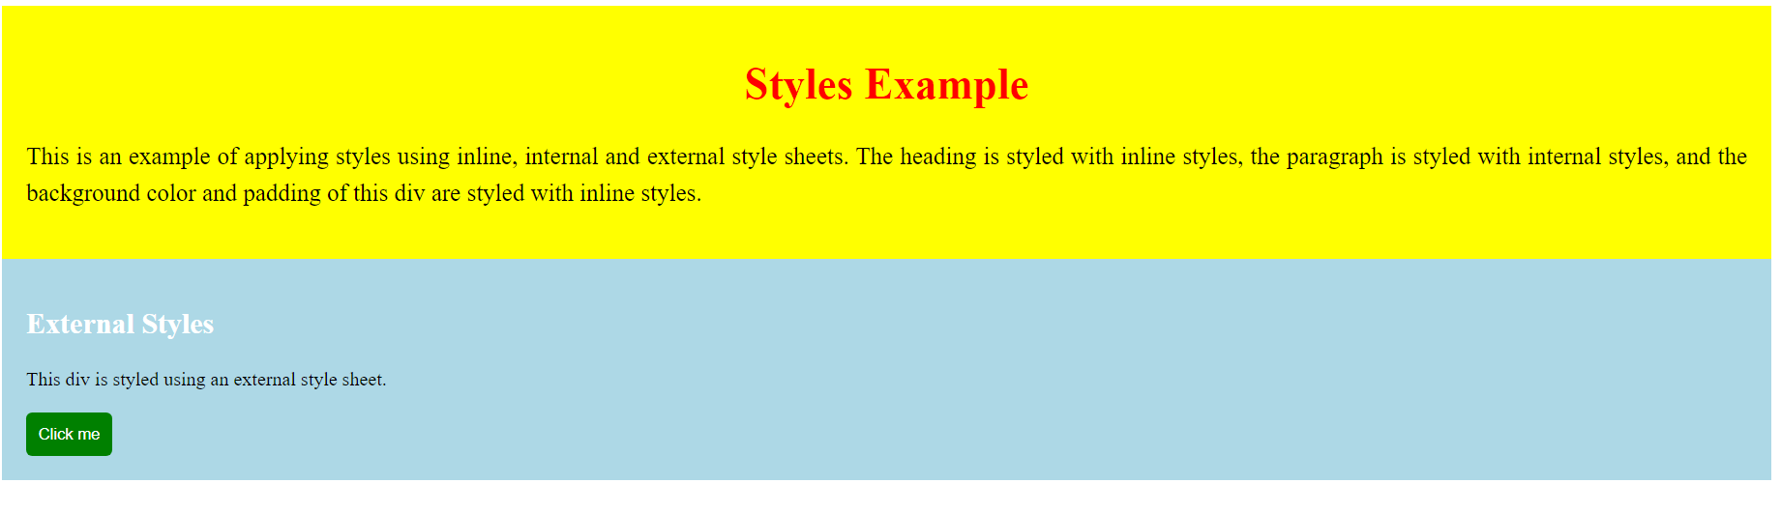

Name: Deepankar Sharma

Course: BCA

University Roll No: 2092014

Subject: Scripting Languages

Date:

**Practical 03: WAP to create a hyperlink and change the background color to blue.**

<!DOCTYPE html>

<html lang="en">

<head>

<meta charset="UTF-8">

<meta http-equiv="X-UA-Compatible" content="IE=edge">

<meta name="viewport" content="width=device-width, initial-scale=1.0">

<title>Document</title>

</head>

<body bgcolor="lightblue">

<a href="https://github.com/ideepankarsharma2003">This is my github profile</a>

</body>

</html>

OUTPUT:-



Name: Deepankar Sharma

Course: BCA

University Roll No: 2092014

Subject: Scripting Languages

Date:

**Practical 04: WAP to design registration form using html.**

<!DOCTYPE html>

<html lang="en">

<head>

<meta charset="UTF-8">

<meta http-equiv="X-UA-Compatible" content="IE=edge">

<meta name="viewport" content="width=device-width, initial-scale=1.0">

<title>Document</title>

</head>

<body>

<h2>Registration Form</h2>

<form action="" method="post">

<label for="username">Username:</label>

<input type="text" id="username" name="username" required><br><br>

<label for="email">Email:</label>

<input type="email" id="email" name="email" required><br><br>

<label for="password">Password:</label>

<input type="password" id="password" name="password" required><br><br>

<label for="confirm_password">Confirm Password:</label>

<input type="password" id="confirm_password" name="confirm_password" required><br><br>

<label for="gender">Gender:</label>

<input type="radio" id="male" name="gender" value="male" required>

<label for="male">Male</label>

<input type="radio" id="female" name="gender" value="female" required>

<label for="female">Female</label>

<input type="radio" id="other" name="gender" value="other" required>

<label for="other">Other</label><br><br>

<label for="dob">Date of Birth:</label>

<input type="date" id="dob" name="dob" required><br><br>

BCA Student: 2022<input type="checkbox" name="" id=""> 2023<input type="checkbox" name="" id=""><br><br>

<input type="submit" value="Register">

</form>

</body>

</html>

OUTPUT:-

